# Report on Rocker-Bogie Suspension

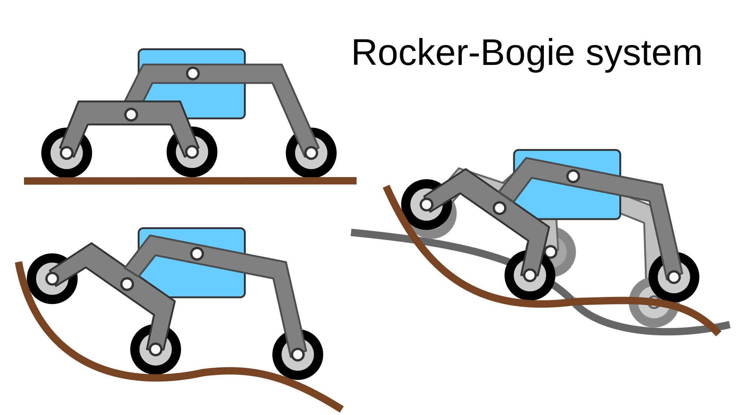

# Introduction -

* Initially designed by NASA and JPL , to counter the problem faced by conventional suspension when they encounter a low gravity environment.
* The term “rocker” describes the rocking aspect of the larger links present on each side of the suspension system and balances the bogie as these rockers are connected to each other and the vehicle chassis through a selectively modified differential.
* As per the acute design, one end of a rocker is fitted with a drive  
  wheel and the other end is pivoted to a bogie which provides required motion and degree of freedom.
* In the system, “bogie” refers to the conjoining links that have a drive wheel attached at each end.

# History and past use -

* Researchers mainly focus on wheeled locomotion for rovers because of its

locomotive ease and advantages and among wheeled locomotion design, the rocker bogie suspension system based design remains most favoured.

* The ancient FIDO rover and the Sojourner contain 6 independently steered

and driven wheels suspended from a rocker-bogie mechanism for maximum suspension and ground clearance.

* The objective behind the evolution of rocker bogie suspension system is to develop a system which minimizes the energy consumption, the vertical displacement of the rover’s centre of mass and its pitch angle.

# Principle -

* The rocker-bogie design consists of no springs and stub axles in each wheel which allows the chassis to climb over any obstacles that are up to double the wheel's diameter in size while keeping all wheels on the ground maximum time.
* Systems employing springs tend to tip more easily as the loaded side yields. Depending upon the centre of overall weight, any vehicle developed on the basis of Rocker bogie suspension can withstand a tilt of at least 50 degrees in any direction without overturning.
* Generally this system uses six wheels, each having an independent mechanism for motion and in which the two front and two rear wheels have individual steering systems which allow the vehicle to turn in place as 0 degree turning ratio. Every wheel also has thick cleats which provides grip for climbing in soft sand and scrambling over rocks with ease.

# Problems to tackle -

* It is highly unstable at high speeds. At high speeds it experiences head on collision of wheels with obstacles. This would cause an impulsive force to act on front wheels. This impulse may damage the system.
* Optimization of the design to tackle the terrain most easily as there are a lot of design parameters to consider.

# Sources -

* OSR Journal of Mechanical and Civil Engineering (IOSR-JMCE)

e-ISSN: 2278-1684,p-ISSN: 2320-334X, Volume 12, Issue 3 Ver. III (May. - Jun. 2015), PP 64-67

# Further reference -

* Volume: 16 issue: 6,

Article first published online: November 11, 2019; Issue published: November 1, 2019

Received: July 30, 2019; Accepted: September 23, 2019

[Hari Nayar](https://journals.sagepub.com/action/doSearch?target=default&ContribAuthorStored=Nayar%2C+Hari)1, [Junggon Kim](https://journals.sagepub.com/action/doSearch?target=default&ContribAuthorStored=Kim%2C+Junggon)1, [Brendan Chamberlain-Simon](https://journals.sagepub.com/action/doSearch?target=default&ContribAuthorStored=Chamberlain-Simon%2C+Brendan)1, [Kalind Carpenter](https://journals.sagepub.com/action/doSearch?target=default&ContribAuthorStored=Carpenter%2C+Kalind)1, [Michael Hans](https://journals.sagepub.com/action/doSearch?target=default&ContribAuthorStored=Hans%2C+Michael)1, [Anna Boettcher](https://journals.sagepub.com/action/doSearch?target=default&ContribAuthorStored=Boettcher%2C+Anna)1, [Gareth Meirion-Griffith](https://journals.sagepub.com/action/doSearch?target=default&ContribAuthorStored=Meirion-Griffith%2C+Gareth)1, [Brian Wilcox](https://journals.sagepub.com/action/doSearch?target=default&ContribAuthorStored=Wilcox%2C+Brian)1, [Brian Bittner](https://journals.sagepub.com/action/doSearch?target=default&ContribAuthorStored=Bittner%2C+Brian)2

Robotics and Mobility Systems, California Institute of Technology, NASA Jet Propulsion Laboratory, Pasadena, USA

Robotics Institute, University of Michigan, Ann Arbor, USA